LESS IS MORE: Small Screens, Big Challenges
- 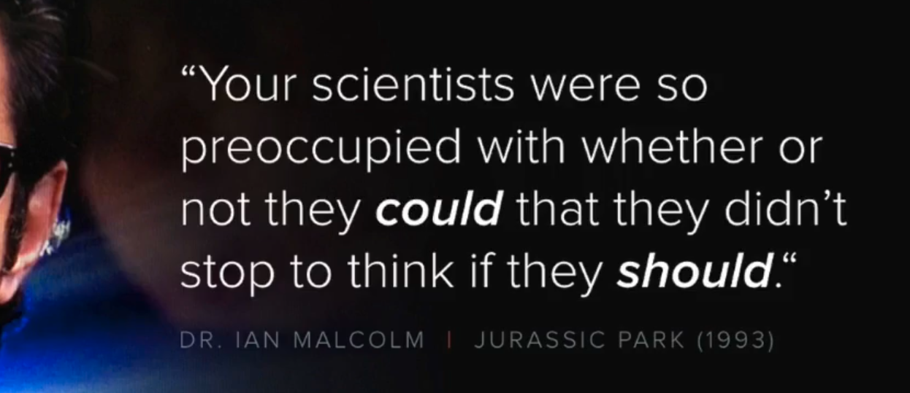
- this is most true especially when it comes to mobile design, cause there’s still too much on the screen
- 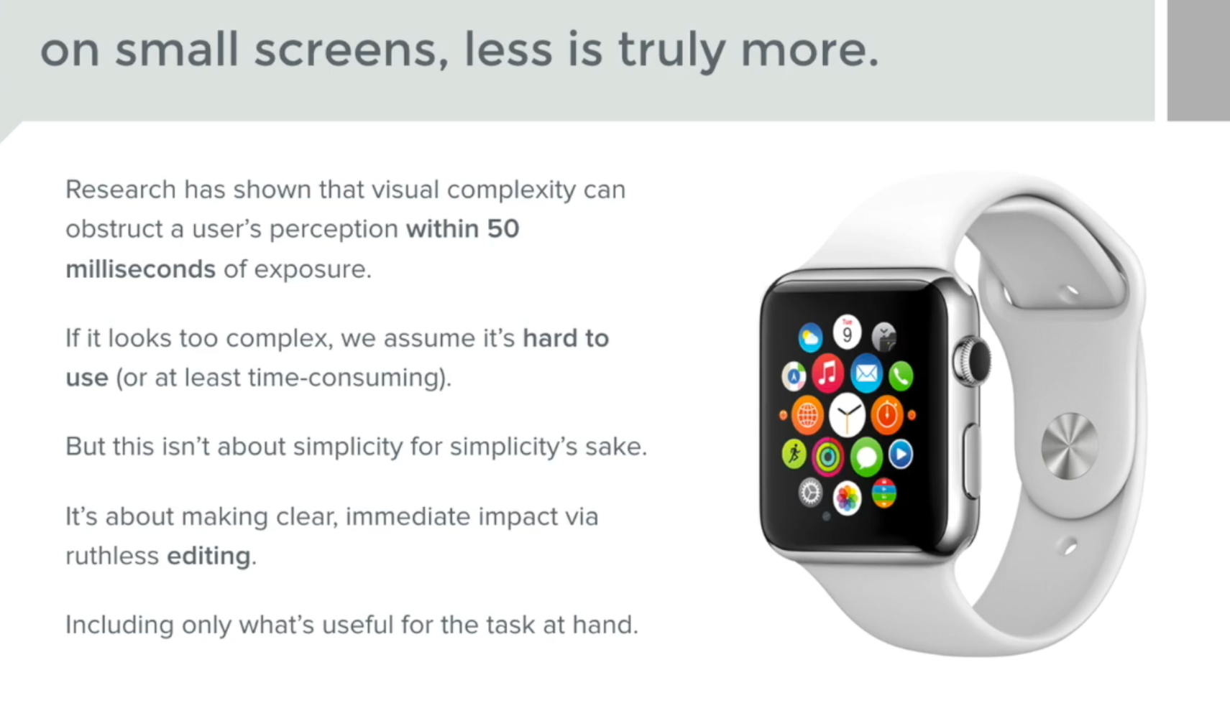
- 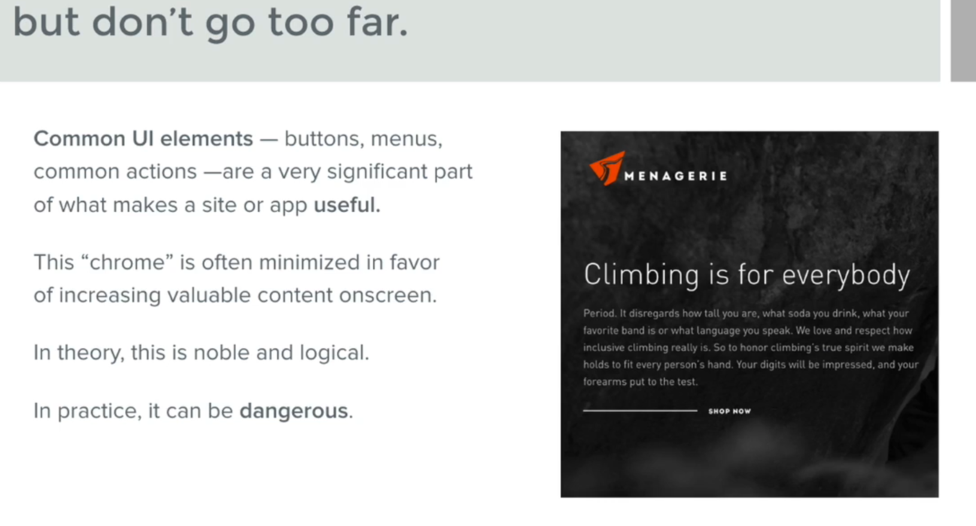
- the design by the right is a good design, but the shop now on the screen is the same color as everything else, and with a line?, it doesn’t seem interactive. it’s a flat design, like a magazine if you will, a user’s mental model would be closer to a button
- 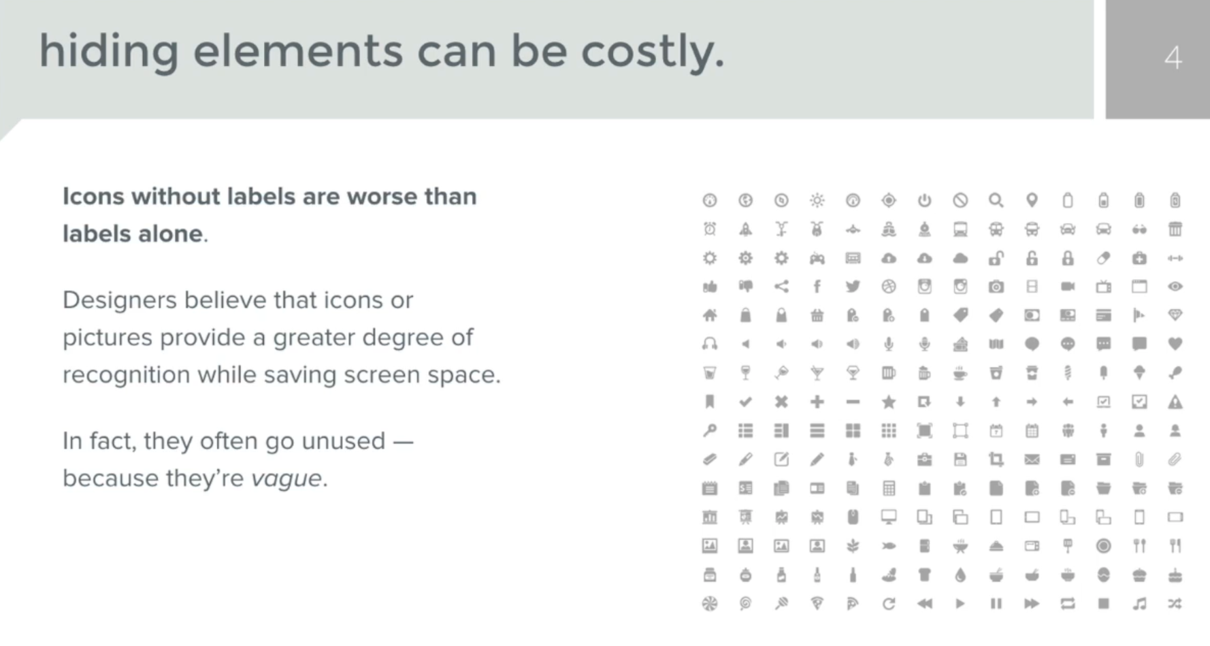
- 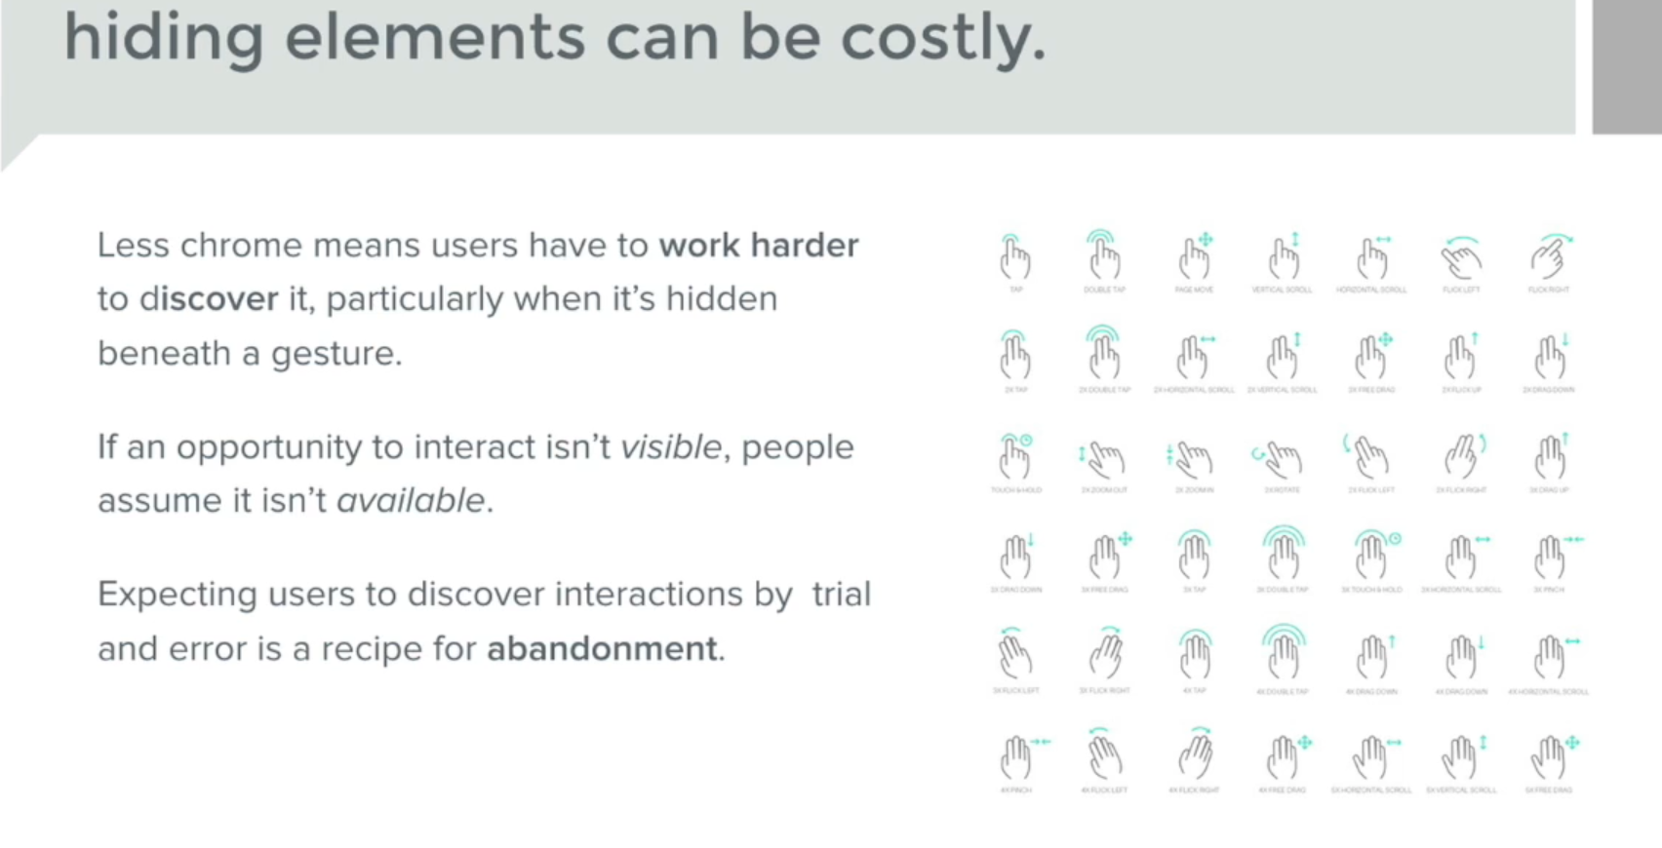

  - "Less Chrome": In user interface (UI) design, "chrome" refers to all the visual elements that are not the primary content but help the user interact with the application. Think of it as the "frame" around the "picture." This includes things like:
    - Toolbars
    - Menus
    - Buttons
    - Scrollbars
    - Navigation bars
    - Icons for actions (like save, share, settings)
    - Window borders
"Less chrome" means a design approach that minimizes or removes these visible UI elements to create a cleaner, more minimalist, or content-focused interface. The idea is to reduce visual clutter and allow the user to focus on the main task or content.
  - "Means users have to work harder to discover it": If you remove visible buttons, menus, or other controls, users can't immediately see where to click or what actions are available. They then have to:
    - Guess: Try to figure out where a feature might be.
    - Explore: Tap around, swipe, or long-press to see if anything happens.
    - Remember: If they do discover a hidden feature, they need to remember how to access it next time.
  - "Particularly when it's hidden beneath a gesture": This is the crucial part. A "gesture" is an action performed on a touchscreen (like swiping, pinching, tapping and holding, double-tapping, etc.) that triggers a function.
    - Unlike a visible button that clearly indicates its purpose, a gesture provides no immediate visual cue that it exists or what it does.
    - If a menu, a setting, or an important action is only accessible by performing a specific, non-obvious gesture, users are highly unlikely to discover it on their own without explicit instruction or trial-and-error.
In essence, the statement highlights the trade-off between minimalism/cleanliness and discoverability/usability.
  - The Benefit of Less Chrome: A clean interface can look elegant, reduce cognitive load by removing distractions, and allow the content to shine.
  - The Downside of Too Much Less Chrome (especially with hidden gestures): While aesthetically pleasing, it can make an application much harder to learn and use. Users get frustrated when they can't find basic functions, and they might abandon the app if it requires too much effort to figure out.
Think of it this way: Imagine a TV remote control with no buttons visible. To change the channel, you have to swipe up with two fingers. To adjust the volume, you pinch. While it might look sleek, you'd never know how to use it without being told, or by spending a lot of time experimenting.
Good UI design aims to find a balance, ensuring that essential and frequently used features are easily discoverable, even if some less critical ones are hidden to maintain a cleaner look.

